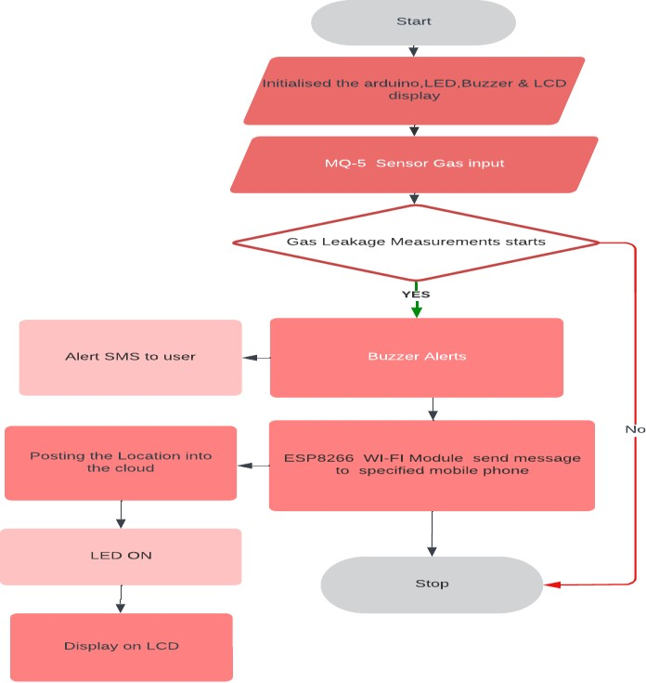

Project Design Phase-II Data Flow Diagram &User Stories

|  |  |
| --- | --- |
| Date | 03October 2022 |
| Team ID | PNT2022TMID34760 |
| Project Name | Gas Leakage Monitoring And Alerting System |
| Maximum Marks | 4 Marks |

# Data Flow Diagrams:

A Data Flow Diagram (DFD) is a traditional visual representation of the information flows within a system. A neat and clear DFD can depict the right amount of the system requirement graphically. It shows how data enters and leaves the system, what changes the information, and where data is stored.

Example: DFD Level 0 (Gas Leakage Monitoring And Alerting System)

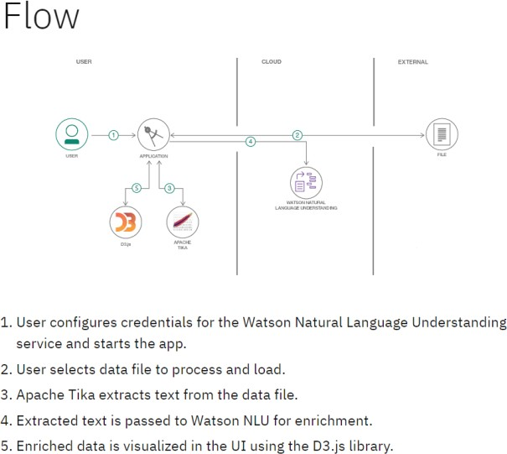

# Example: [(Simplified)](https://developer.ibm.com/patterns/visualize-unstructured-text/)

**User Stories**

Use the below template to list all the user stories for the product.

|  |  |  |  |  |  |  |
| --- | --- | --- | --- | --- | --- | --- |
| **User Type** | **Functional**  **Requirement (Epic)** | **User Story Number** | **User Story / Task** | **Acceptance criteria** | **Priority** | **Release** |
| Customer (Mobile user) | Registration | USN-1 | As The user free Register mobile app makes it easy for you to add the products you own. | I can access my account / dashboard | High | Sprint-1 |
|  |  | USN-2 | As a user I can operate in any location in particular app | I can receive notification through g mail | High | Sprint-1 |
|  |  | USN-3 | As a user I can Login in mobile phone active the extension go to settings and login with  phone tab to enable and configure the settings | I can register & access the dashboard with play store Login | Low | Sprint-2 |
|  |  | USN-4 | As a user, I can register for the application through Gmail |  | Medium | Sprint-1 |
|  | Login | USN-5 | As a user, I can log into the application by entering email & password |  | High | Sprint-1 |
|  | Dashboard |  |  | Software product accept y the users |  |  |
| Customer (Web user) | Subscription services | USN-6 | As a customer to use the web form of the work wide technology | Individual authorized web user portal | Medium | Sprint-1 |
| Customer Care Executive | Email/chat | USN-7 | Professional responsible for communicating The regarding service expectations | I can services for company’s success | High | Sprint-2 |
| Administrator | Manager system | USN-8 | Descriptive of a product feature from the perspective of the person requesting the features | Express criteria clearly, in simple language | Medium | Sprint-1 |
|  |  |  |  |  |  |  |
|  |  |  |  |  |  |  |
|  |  |  |  |  |  |  |